Press Statement
- Our party's attention has been seriously drawn by the Israeli military intervention, which resulted in the assassination of Iran's high-ranking military leadership and nuclear scientists, the attack on nuclear facilities, and the subsequent deadly attack by the US on three nuclear facilities in Iran using bunker buster bombs.
- US imperialism and the Israeli expansionism under its patronage used to argue that such attacks were necessary upon Iran because their existence would be threatened by the Iranian regime if allowed to become a nuclear power, but now the US and Israel advocate that the current state structure of Iran must be changed at all costs and a new state that works in their interests should be established in its place.
- Our party strongly condemns and denounces the brutal military attack upon Iran and the interference regarding regime change by US imperialism and Israeli expansionism because what kind of regime is to be established in Iran rests on the sovereign right of the Iranian people, and supports Iran's rights to self-defense.
- Our party demands an immediate halt to the indiscriminate attacks on Iran by US imperialism and Israel and strongly opposes US activities that are pushing the world towards a genocidal Third World War.
- Our party strongly opposes the direct intervention in Iran's national independence by US imperialism and its follower Israel and expresses solidarity with the Iranian people who are resisting such interference. In addition, it strongly calls on the justice-loving masses around the world to oppose US imperialism and stand by the Iranian people.
Date: 6/25/2025
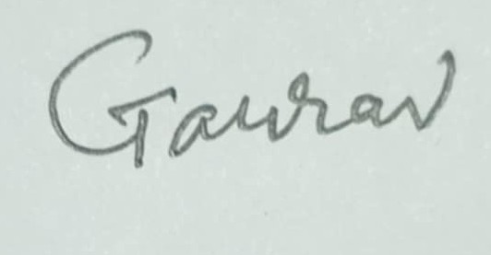
Gaurav
Acting General Secretary

